SPLUNK CLOUD

Performing a Query to find a Fail
(Opensourse)
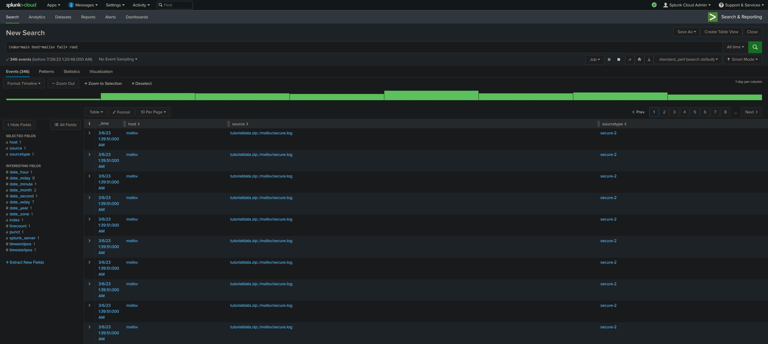
Summary
- Search through indexed data
- Evaluate search results
- Identify different data sources
- Locate failed SSH login(s) for the root account

Results
Query: index=main host=mailsv fail* root

- 1 pattern based on a sample of 346 events
- (Thursday) Failed password for invalid user appserver
- Over 300 failed SSH logins for the root

